**6.6 Reproduction**

**6.6.1 Draw and label diagrams of the adult male and female reproductive systems.(1)**

**Male reproductive system:**

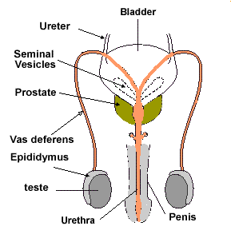

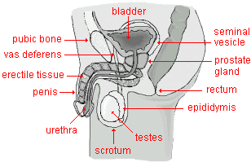

**Female reproductive system:**

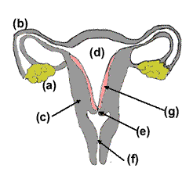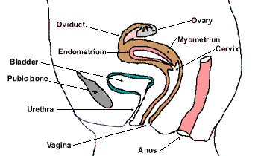

**6.6.2 Outline the role of hormones in the menstrual cycle, including FSH (follicle stimulating hormone), LH (luteinizing hormone), estrogen and progesterone.(2).**

* Sexual maturity in women is marked by the beginning of the menstrual cycles. These cycles coordinate the development and release of an egg with the conditions required in the uterus to support a pregnancy.
* The cycle is controlled by hormones from both the brain (FSH and LH) and the ovary(oestrogen and progesterone).
* The natural cycle repeats until there is either a pregnancy or the woman reaches menopause and the end of the reproductive phase of her life.
* FSH and LH are two hormone that are active at significant phases of human development including primary and secondary sexual characteristics. They are both significant hormones in the primary sex determination. Following puberty human become fertile and in females this is manifest as the menstrual cycle.

**Anterior Pituitary Hormones:**

**Follicle Stimulating hormone (FSH)**

* Stimulates the development of a primary follicles (oocytes).
* Increases the number of follicular cells which in turn produce oestrogens.
* Produces follicular fluids.
* Develops the oocyte in the follicle.

**Luteinising Hormone (LH):**

* surges in mid cycle (12 days) to bring about ovulation.
* [high LH](http://click4biology.info/c4b/6/images/6.6/Alex_Tsafriri.pdf) is associated with a resumption of meiosis in the oocyte. Meiosis has been arrested in Prophase I since the embryonic stage. Only at the point of fertilisation does meiosis complete.
* stimulates the development of the corpus luteum.

**Ovarian Hormones**

**Oestrogen:**

* Stimulates the development of the endometrium (lining of the uterus) and it associated blood supply.
* During the first half of the cycle there is positive feedback through increased sensitivity of the follicle cells to FSH (Up-regulation of receptors on the follicular cell plasma membrane).
* During the second half of the cycle (high oestrogen) there is negative feedback on FSH and LH.

**Progesterone:**

* maintains the lining of the endometrium
* negative feedback on FSH and LH

**6.6.3 Annotate a graph showing hormone levels in the menstrual cycle, illustrating the relationship between changes in hormone levels and ovulation, menstruation and thickening of the endometrium.(2 )**

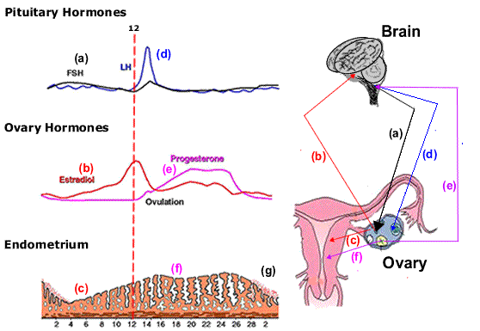a) Follicle Stimulating Hormone (FSH) is secreted by the pituitary gland of the brain and stimulates the development of a primary follicle.

(b) Primary follicle cells secrete oestrogen which in turn increase the secretion of FSH in a positive feedback.

(c) The oestrogen thickens the lining of the uterus in preparation for a fertilised egg.

(d) The peak of oestrogen secretion at day 12 causes the pituitary to release a surge of LH. This loosens the now mature egg which is released in ovulation

* LH reduces the secretion of Oestrogen
* LH stimulates the empty follicle to develop into the corpus luteum

e) Progesterone and oestrogen together stop any more LH and FSH being secreted from the pituitary. (negative feedback)

* This prevents further follicle development or ovulation.

(f) Progesterone maintains the lining of the thickened endometrium in preparation for the implantation of a fertilised egg.

(g) If implantation does not take place then the Corpus luteum degenerates and fails.

The progesterone production stops.

* The endometrium breaks down and the 'menstrual period' begins
* The inhibition of FSH and LH by ovarian hormones has been removed and so they begin their secretions again of FSH.
* A new cycle has begun.

**6.6.4 List three roles of testosterone in males.(1)**

1. Week 7 of embryonic development, testosterone initiates the development of male genitalia.

2. Around mid teens, testosterone initiates the development of secondary sexual characteristics

* increase in muscle mass
* increase in the length of the long bones (height)
* increase in the length of the vocal cords (voice deepens)
* spermatogenesis
* growth of the penis and testis

3. Post puberty testosterone maintains the production of sperm cells and the male sex drive.

**6.6.5 Outline the process of in vitro fertilization (IVF).(2)**

One of the common reasons that a couple cannot produce a pregnancy is the low sperm count of the male. This can be rectified by concentrating the male sperm before being placed into the uterus of the female using a catheter.

Other reasons for infertility include stenosis (blockage) of the cervix which again can be overcome by simple procedures and the mechanical introduction of sperm through this passage (as above).

In more complex cases of infertility it is necessary to fertilize the egg cell outside of the body before introducing the embryos into the uterus for implantation.

One of the assisted reproductive technologies is called 'In Vitro fertilisation' or IVF. First performed by Sir Robert Winston in 1978 Oldham England. Louise Brown was the first of millions of '*test tube babies*'.

The first stage of the technique maybe preceded by the taking of inhibitors of FSH and LH but this stage maybe missed through monitoring using ultrasound.

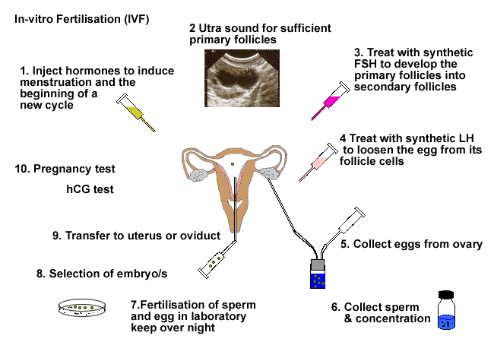

**6.6.6 Discuss the ethical issues associated with IVF.(3)**

Advantages of IVF: there are as many reasons for this treatment as there are people seeking this treatment. As examples

* over comes infertility
* allow families for people who must be sterilised e.g.. radiography/chemo therapy cancer patients

Disadvantages of IVF:

* what happens to unwanted embryo's
* what happens to orphaned embryo's
* should infertility be by-passed